Documentation of the program code

**Course Management System**

Author: Serhat Güler

Data: 11/10/2024

# History of technical documentation

### Author

|  |  |  |
| --- | --- | --- |
| Fac. No | Name | E-mail |
| 273222035 | Serhat Gurel | [gurelserhatt@gmail.com](mailto:gurelserhatt@gmail.com) |

**Version history**

|  |  |  |  |
| --- | --- | --- | --- |
| Version | Data | Author | Description |
| 1.0 | 11/10/2024 | Serhat Gurel | I met with the project manager and was given the application design via SwiftUI  Ideas were exchanged about the design and content of the application. |
| 1.1 | 15/11/2024 | Serhat Gurel | The first coding of the application has started. The design and login screen have been determined.  After the login screen of the application, the process under the name of student management system was evaluated and the writing of the code was started. |
| 1.2 | 25/11/2024 | Serhat Gurel | All need areas in the student management system were determined and the writing of the code continued  It was decided that the application would reach its final version and developments and improvements were made to the code.  Some design changes within the application were decided with the project manager. |
| 1.3 | 28/11/2024 | Serhat Gurel | After the design change, changes were made to the code in accordance with the design.  Code designs have begun to put the project into practice.  The cover image on the application opening screen was determined. This was integrated into the code and took its final form. |
| 1.4 | 30/11/2024 | Serhat Gurel | The application logo image was determined. The logo was added to the application and the project was completed. |
| 1.5 | 05/02/2024 | Serhat Gurel | The slogan for the application was "Future Begins Here". |

# Content

1. INTRODUCTION 4
2. DETAILED DESIGN 4
   1. Codes For Application 4
   2. Sample user interface 6
   3. Title: Future Begins 6
   4. Functional Icons (Bottom Section) 6
   5. Design Note 7
3. TESTING 4

# Introduction

***The CourseManagament is a SwiftUI-based interface designed for a university student management app. This view focuses on presenting detailed information about a specific student, including their personal details, academic performance, enrolled courses, and contact information. It provides a clean and dynamic user experience, allowing users to navigate through different sections using a scrollable tab interface.***

# Detailed design

## Codes for Application

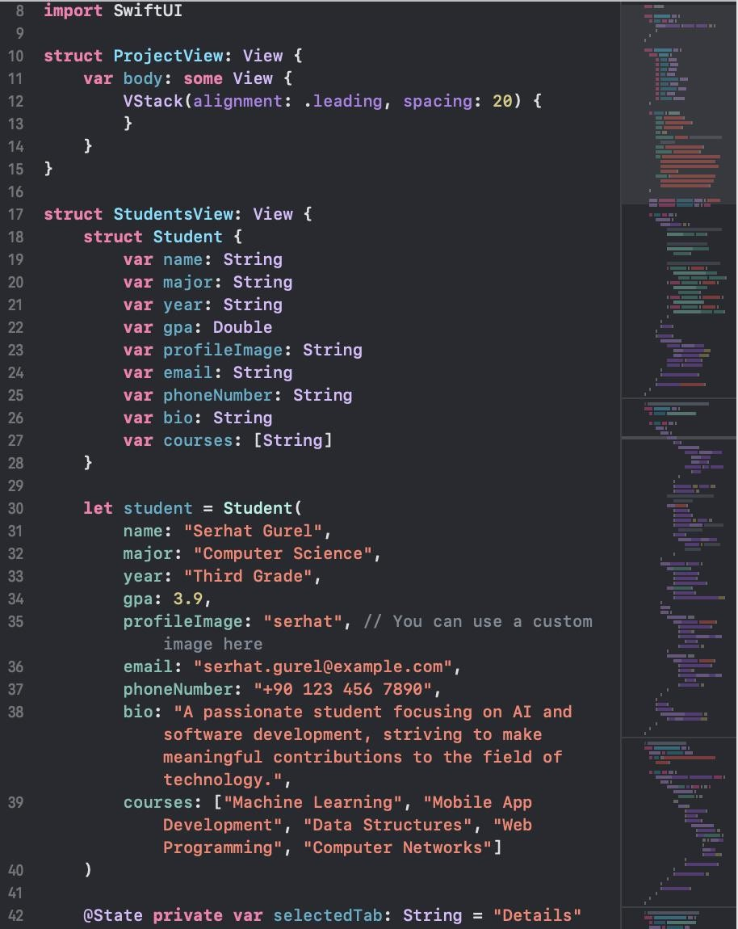

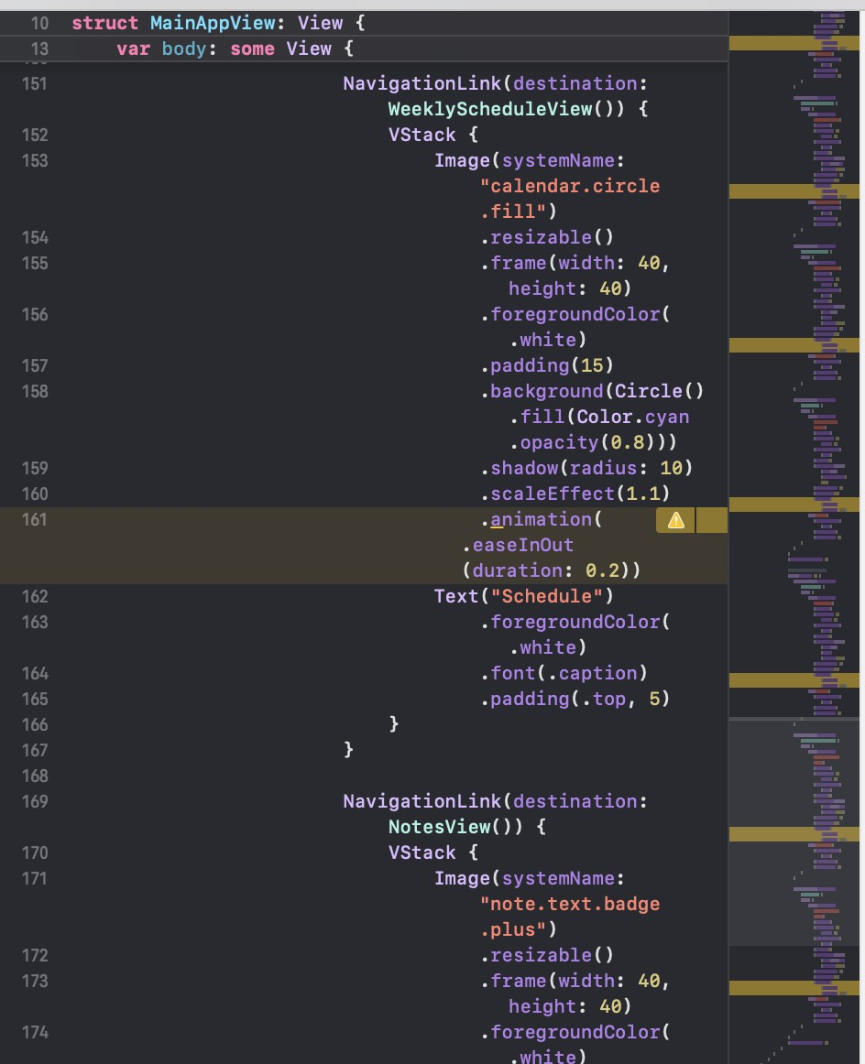

* 1. **Sample user interface**

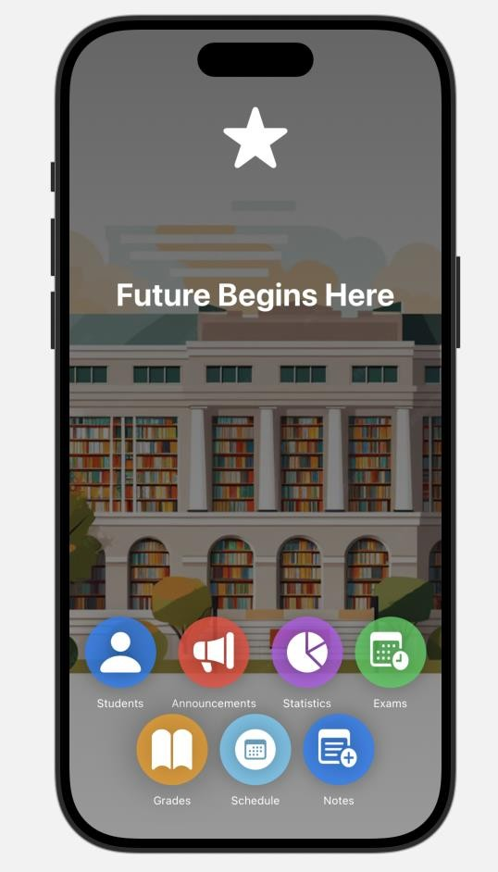

# 2.3Title: Future Begins Here

**Header Icon**: A white star symbol at the top of the interface, representing the theme or focus of the app. **Background**: A modern illustration of a library or educational building with bookshelves, evoking an academic theme.

# 2.4 Functional Icons (Bottom Section):

* + - 1. **Students**: Blue circular icon with a person silhouette, representing the student management section.
      2. **Announcements**: Red circular icon with a megaphone, for viewing or managing important announcements.
      3. **Statistics**: Purple circular icon with a pie chart, for analyzing data or statistics.
      4. **Exams**: Green circular icon with a calendar, representing the exams or schedules section.
      5. **Grades**: Yellow circular icon with a book, for accessing grades.
      6. **Schedule**: Light blue circular icon with a calendar grid, for managing the student timetable.
      7. **Notes**: Blue circular icon with a notepad and a pen, for managing or taking notes.

# Design Notes:

* The design combines vibrant colors for icons with a professional academic theme.
* Circular icons are evenly spaced at the bottom, making navigation intuitive and visually appealing.
* The typography is clean, modern, and centered, emphasizing the educational purpose of the app.

# Testing

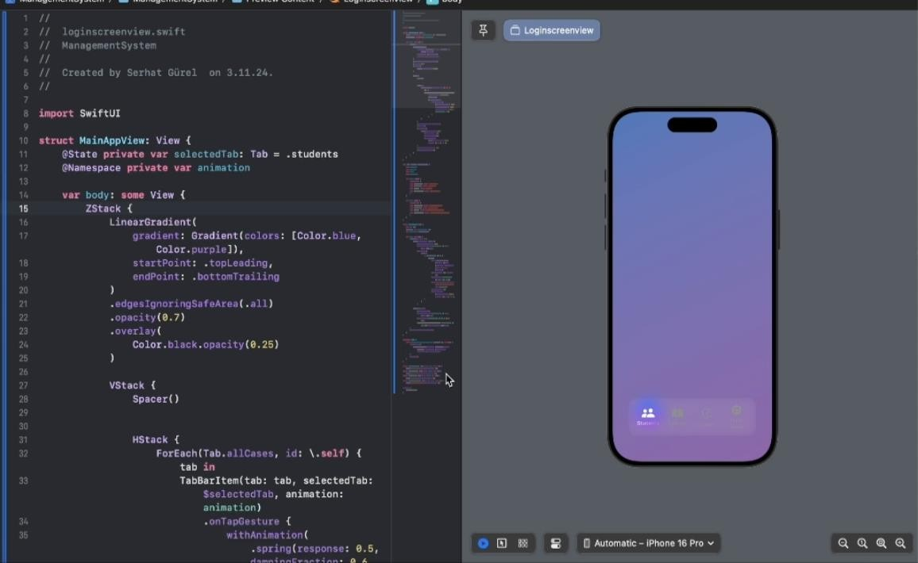

***I had to change the design animation in this image because it supports it in the latest iOS 15.***

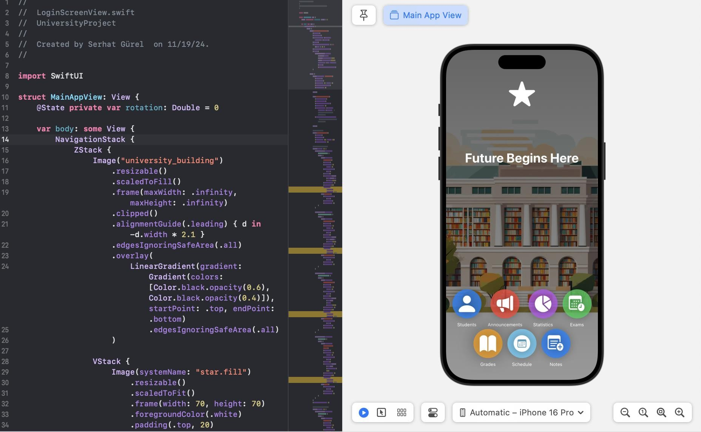

***We updated the program in the image according to the iOS 18.1 code, redesigned the design and ensured that it was tested.***

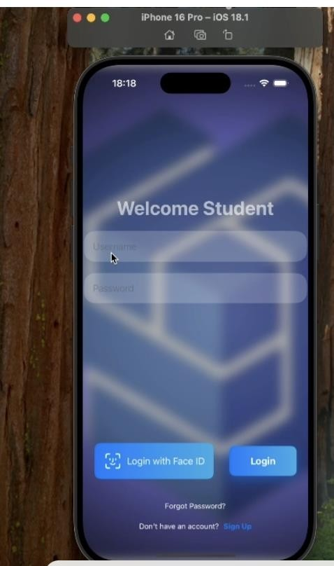

***Fixed the problem of not being able to proceed to the next field after entering the username and password during the login screen transition.***

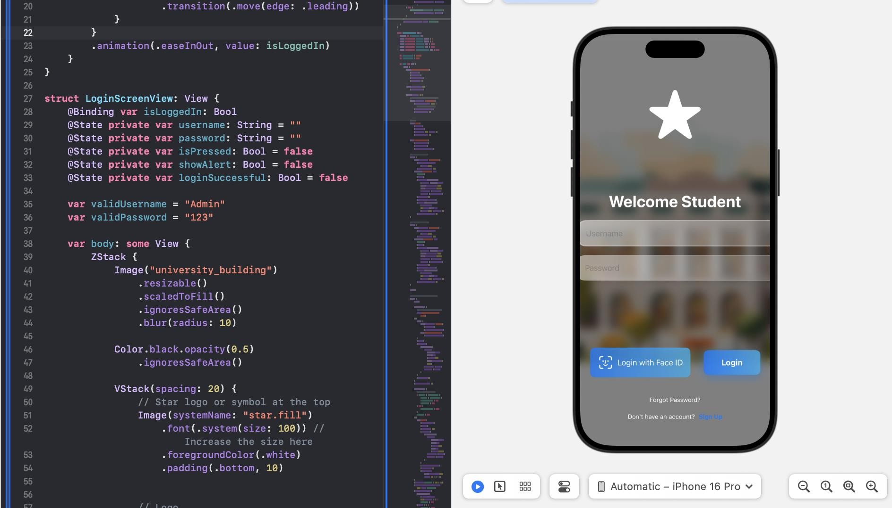

***Updated the login screen and found that the error was caused by a visual mismatch. Removed the image from the background and applied a different design.***

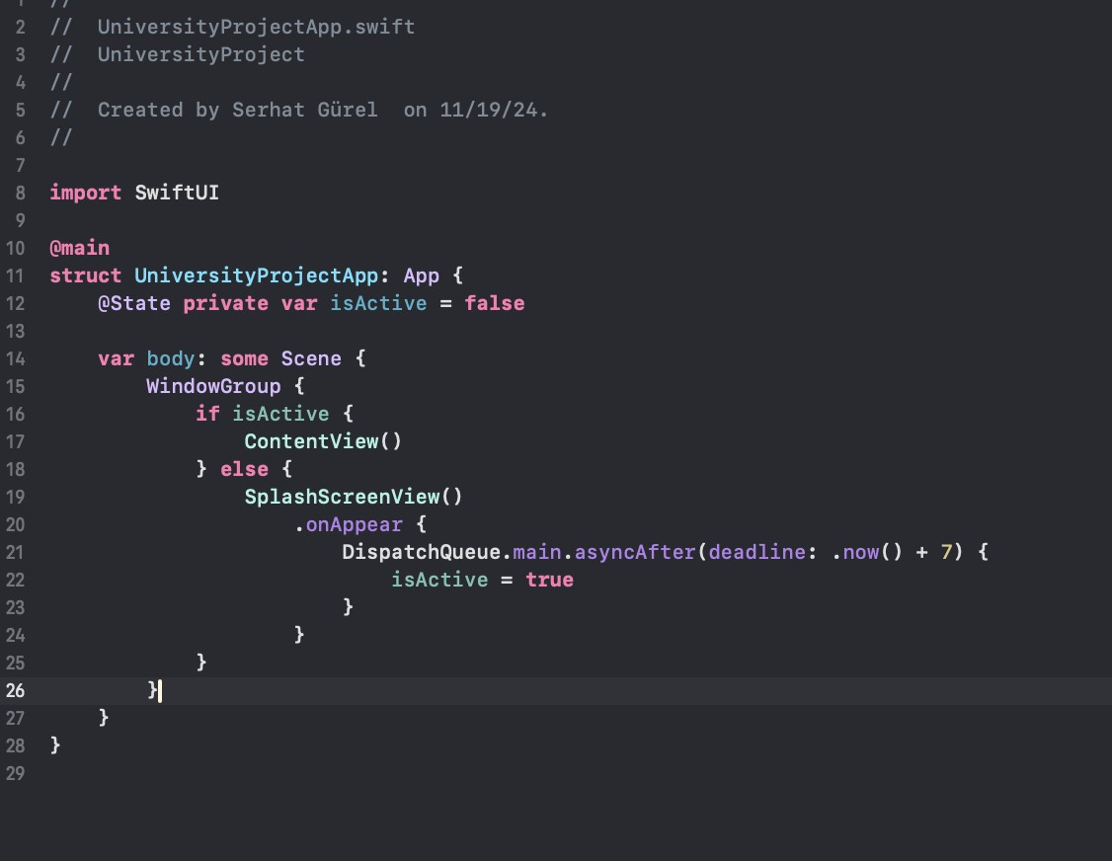

**The redirection error in the application opening screen image in the code was fixed with the SplashScreenView code.**

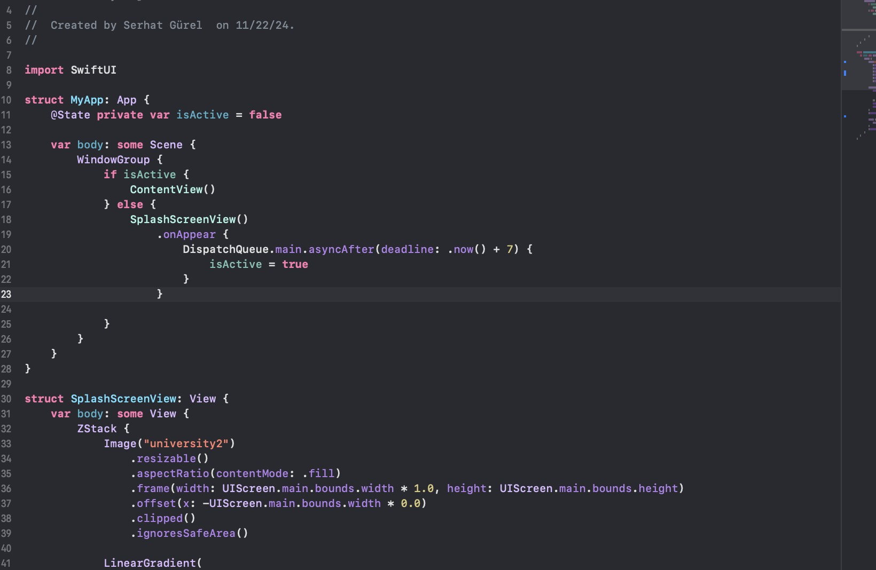

### SplashScreenView application and code components that make the code work smoothly